**Global Temperature and Cairo City Data Analysis**

**Introduction:** The world temperature is changing every year globally and locally from time to time. This file contains comparison between global average temperature and the average temperature of Cairo City the Capital of Egypt mainly and also with New York and Riyadh Cities. This research has been conducted on the 18th of June 2019.

**Goal of this Study:** in this file we are making a data analysis to show the difference between the average global temperature and Cairo City average temperature and how the global climate has changed during the past few hundred years.

**Steps taken to conduct this Analysis:**

* **Extracting Cities data to see the closest city to my location in Egypt from the Udacity database using the SQL Code:**

|  |
| --- |
| **SELECT cl.country,  cl.city FROM city_list cl WHERE cl.country= 'Egypt';** |

* **Extracting Cairo City data from the database using the SQL Code:**

|  |
| --- |
| **SELECT cd.country,  cd.city,  cd.avg_temp, cd.year FROM city_data cd WHERE cd.city= 'Cairo';** |

* **Extracting New York City data from the database using the SQL Code:**

|  |
| --- |
| **SELECT cd.country,  cd.city,  cd.avg_temp, cd.year FROM city_data cd WHERE cd.city= 'New York';** |

* **Extracting Riyadh City data from the database using the SQL Code:**

|  |
| --- |
| **SELECT cd.country,  cd.city,  cd.avg_temp, cd.year FROM city_data cd WHERE cd.city= 'Riyadh';** |

* **Extracting the global average temperature data using the SQL Code:**

|  |
| --- |
| **SELECT cd.year,  cd.avg_temp FROM global_data cd;** |

* **Downloaded all the previous data in CSV format, uploaded them to Google Drive and combined them in one Google sheet file, each city in a column,** [**Check the file here**](https://docs.google.com/spreadsheets/d/15IWM10vKiYiu4uIDjnqOW8U4mxntYq5XUartpVnfr_M/edit?usp=sharing)**.**
* **Calculated the Moving Average of every 10 years of each city using the function AVERAGE() of the first ten years average temperature then copied the function in each line to complete the Moving Average and the same for each city.**

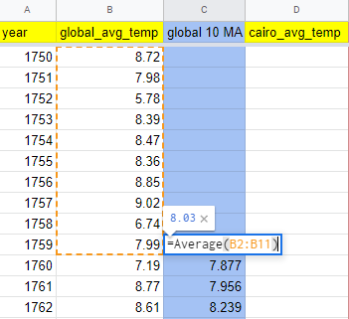

* **Created a Line Chart (Menu > Insert > Chart) then added the Moving average of each Cairo and global data, time by years on X-axis and temperature on Y-axis.**
* **Created new chart to compare between all the four cities.**

**Considered Keys during Visualization process:**

* **Sorting and organizing data correctly so that each city average temperature column is synchronized correctly with the year recorded in.**
* **Using Moving Average for every 10 years recorded average temperature to smooth chart lines and make it easier to spot important events rather than minor events.**
* **Using the time in years on the X-axis and the cities temperature on the Y-axis so we better can visualize the data and see all the cities chart lines beside each other.**
* **Making a grid lines for every 10 years and every 2.5 degrees that makes the chart easier to read.**

**Chart comparing the global moving temperature average and the Cairo City**

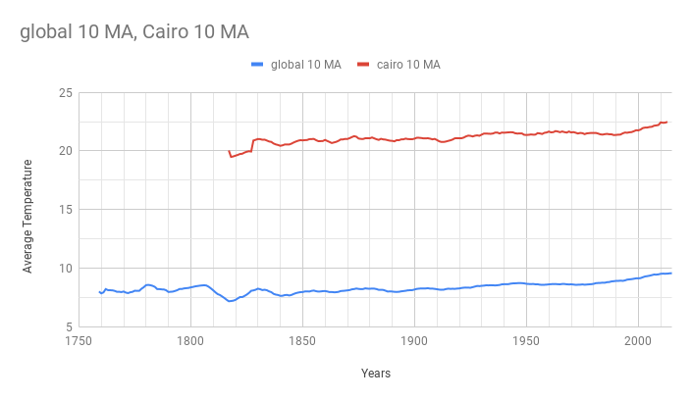

**Observations for Chart 1**

1. **Cairo City Average temperature is much hotter than the global average temperature by at least 10 degrees consistently all the time.**
2. **Cairo City Average temperature has been raised from 20 degrees at 1810s to 25 degrees at 2000s which is 5 degrees raise in approximately 200 years.**
3. **Global temperature is getting hotter by 1 to 2 degrees every 50 years.**
4. **The global average temperature has dropped significantly between 1810 and 1825 and the same happened in Cairo City.**
5. **Maximum average temperature happened during the past hundred years are between 2000 and 2013 for Cairo City and the globe.**

**Chart comparing the global moving temperature average, the Cairo City, Riyadh City and the New York City**

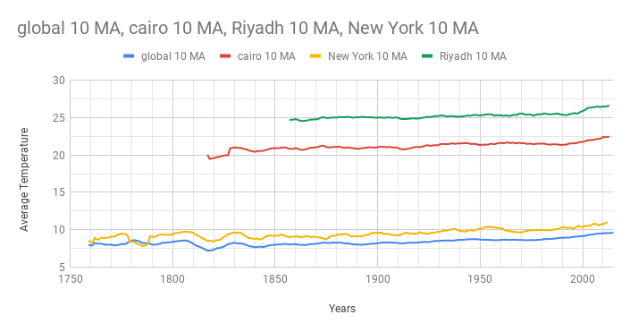

**Observations for chart 2**

1. **Riyadh City is hotter than Cairo City by 7 degrees and both cities are getting much hotter very significantly in the past 20 years (2000- 2013) more than in the past 100 years which is a sign that the middle east is getting hotter.**
2. **New York city temperature is colder than Cairo City by at least 8 degrees consistently.**
3. **All three cities and the global temperature has raised significantly through the past 20 years compared to the past 100 years**

**Full Chart of All years data analysis**

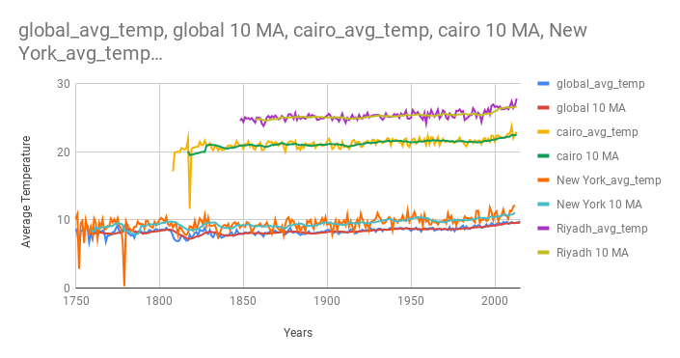

*This research has been conducted by Eng. Mohamed Alsayed on 19th of June 2019 with the help of Udacity Database of Global Temperature Records ©.*